### Deploy Mahjong game on PythonAnywhere

1. Login / Register to PythonAnywhere.
2. Go to Accounts tab and create API Token

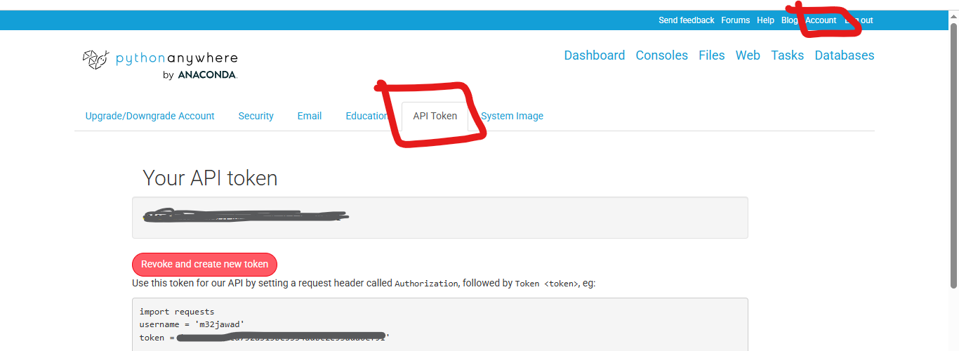

1. Go to consoles tab and select bash console

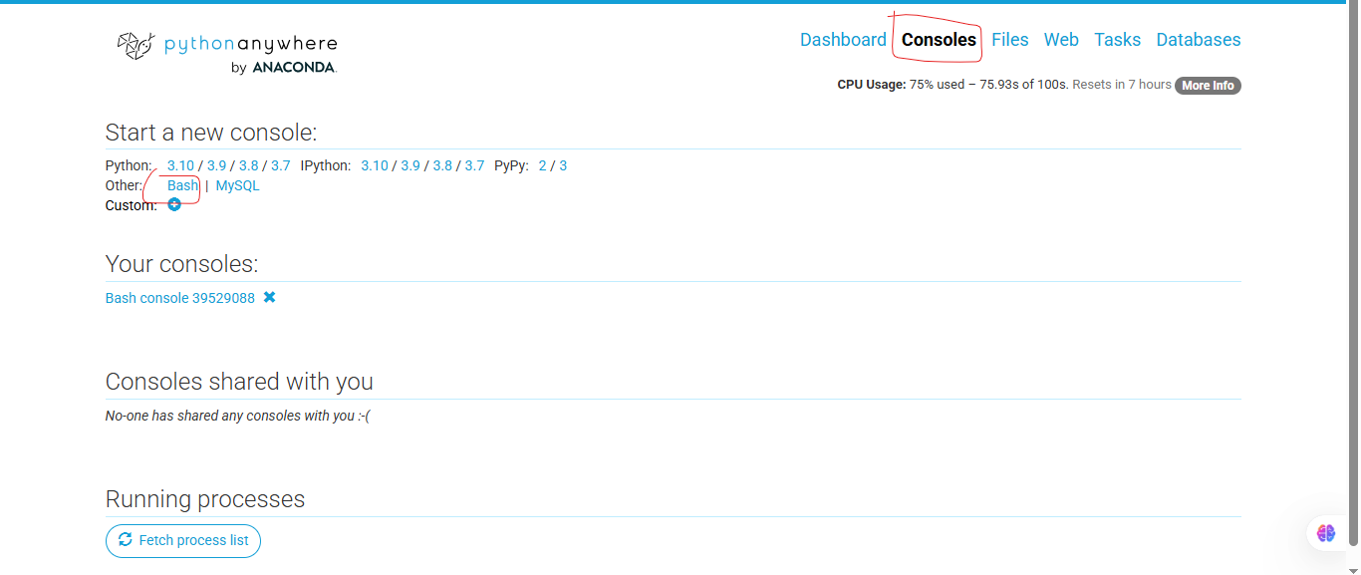

1. In console window enter the following commands to clone the repository containing your game’s code and install required dependencies.

git clone <https://github.com/m32jawad/MahjongGame.git>

cd MahjongGame

git checkout master

pip install --upgrade pythonanywhere

mkvirtualenv my_venv --python=python3.10

pip install flask-socketio gunicorn eventlet

pip install -r requirements.txt

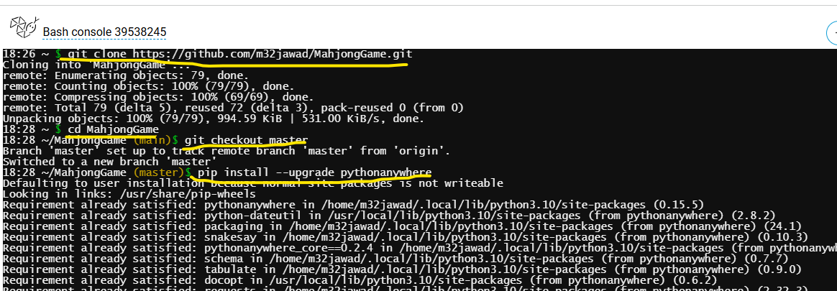

1. Create your website. Replace YOURUSERNAME with your pythonanywhere username

pa website create --domain YOURUSERNAME.pythonanywhere.com --command '/home/YOURUSERNAME /.virtualenvs/my_venv/bin/gunicorn --worker-class eventlet -w 1 --chdir /home/YOURUSERNAME/MahjongGame --bind unix:${DOMAIN_SOCKET} app:app'

now you can access your website YOURUSERNAME.pythonanywhere.com

### 

### Additional Commands

### Getting and listing websites

You can get a list of async websites from PythonAnywhere with this command:

pa website get

You'll get something like this:

domain name enabled

------------------------------- ---------

YOURUSERNAME.pythonanywhere.com True

And you can get the details for one website like this:

pa website get --domain YOURUSERNAME.pythonanywhere.com

...which will display something like this:

----------- -------------------------------------------------------------------------------------------------------------------------

domain name YOURUSERNAME.pythonanywhere.com

enabled True

command /home/YOURUSERNAME/.virtualenvs/my_venv/bin/gunicorn --worker-class eventlet -w 1 --chdir /home/YOURUSERNAME/Flask-SocketIO/example --bind unix:${DOMAIN_SOCKET} app:app

----------- --------------------------------------------------------------------------

### Reloading

If you change the code of your website, you'll need to reload it to activate those changes:

pa website reload --domain YOURUSERNAME.pythonanywhere.com

If all goes well, you'll see this:

< Website YOURUSERNAME.pythonanywhere.com has been reloaded! >

\

~<:>>>>>>>>>

...and if you visit the site, you'll see that it's been updated to run your new code.

### Delete

To delete your website, use this:

pa website delete --domain YOURUSERNAME.pythonanywhere.com

If all goes well, you'll see this:

< Website YOURUSERNAME.pythonanywhere.com has been deleted! >

\

~<:>>>>>>>>>

...and the website will be gone, and replaced with our default "Coming Soon!" page.

Official Article link: <https://help.pythonanywhere.com/pages/FlaskSocketIO/>